CHAPTER 8: The dynamic Earth
Worksheet 8.4

Earthquakes
Answers

1. The following diagram shows a section of the Earth’s crust where an earthquake is being generated.
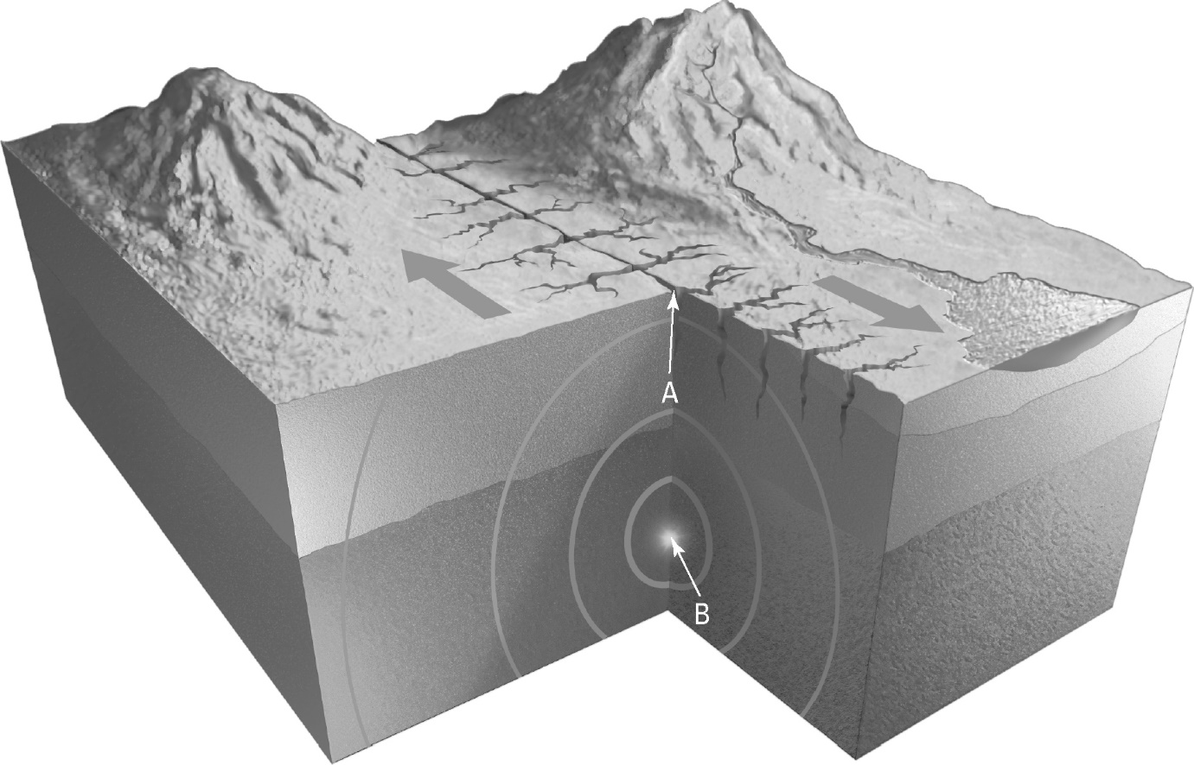
(a) Identify the points labelled A and B:
Epicentre

A:
Focus

B:
(b) Identify the likely cause of the earthquake illustrated.
Sideways movement along a slip-strike (transform) fault at the plate boundary

(c) Australia does not experience many earthquakes. Explain.
The Australian continent is not near a plate boundary or hot spot, so earthquakes do not occur often.

CHAPTER 8: The dynamic Earth
Worksheet 8.4

Page 2

2. The following table provides information about earthquake intensities. The description information is jumbled. Use the letters G–L to match the Richter magnitude and the description of effects.
Richter magnitude | Description of effects
(A) 1.0 | (G) Causes serious damage over very large areas
(B) <3.5 | (H) Can be destructive over a 100 km wide area
(C) <6.0 | (I) Generally noticeable by humans
(D) 6.1–6.9 | (J) Can cause serious damage in areas several hundreds of km across
(E) 7.0–7.9 | (K) Undetectable by humans
(F) ≥8 | (L) Slight damage to well-designed buildings but can cause large cracks and material failure to poorly constructed buildings

A: ………………………….. B: ………………………….. C: …………………………..
L
I
K
D: ………………………….. E: ………………………….. F: …………………………...
J
G
H

3. The following diagram shows how a tsunami forms.
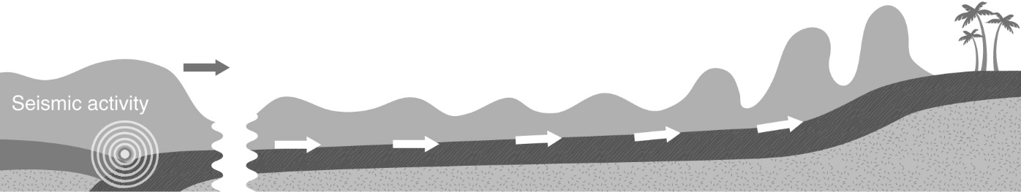

Explain why the height of the wave increases as it approaches the land.
The waves move fast in deep water and slow down in shallow water. The wave crests begin to bunch up in the shallow water as they slow down, eventually merging to produce extremely high waves.

